**PRODUCT REQUIREMENT DOCUMENT (PRD)**

Project name:  **E-Com Web**

Version: **PRD 0.1**

Author: **Group 7**

Date accepted: 2’.04.2020

Launch date: 31’.05.2020

Project owner: **Priyanka Mishra, Avishkar Sharma, Shaashwat Bharadwaj, Priyambada**

Priority: High

## PURPOSE

Purpose of the project is to create an e-commerce website which will help the industries with the difficulties they are facing for supplying products in a better way.

## DETAILED DESCRIPTION OF THE PRODUCT

For an E-commerce website to begin with our strategy was which audience to target and then we will be visualizing the competitors we have in the market, Also know about the website we set a platform on which we have to implement our website & how they operate their large-scale business and what factors they see on how to expand. After that, we decided to create it in a **SQLite** database and an **Intuitive UI/UX design in Bootstrap 4** which is very simple to understand as well as cost effective for us. As soon as we decide our platform on which we will be working on, we have to begin designing our store and products, as well as the features for the website which it will have for the user-base to have the best experience

# Use Cases

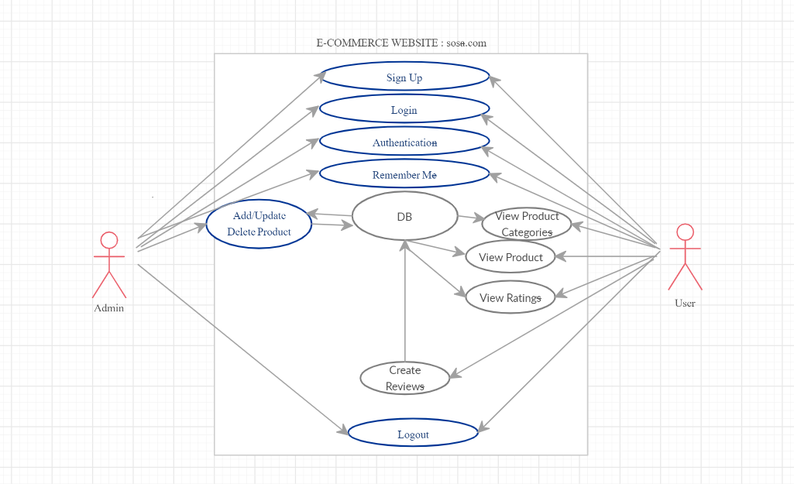

The target audience and the need to understand them:

Before designing the e-commerce website, we need to learn and understand our target audience and what they need if they want something out of our website.

1. Primary Research:

This research is based on understanding the consumers. In order to understand, we can have some kind of interviews or surveys on what they need for themselves. For instance, in this very early pandemic situation around the world people are in need of masks and most importantly food supplies which helps us to give our website a kick start to what we can add and help out the world through this.

When we are conducting our surveys, these are the questions we need answers to so that we can understand the consumer’s perspective:

· What is the most important feature of the product according to the user?

· How are the users interacting with the product?

· Where and how does the product fail in accordance to the consumer expectations and how can we improve?

After we have enough data for the primary research, we can move forward to the next step that is secondary research

2. Secondary Research:

Secondary research will not gain a lot of money and mostly it will not help us get paid here because this is the crucial part of the process where we get to know our target audience and for that we will give demonstrations and discounts for things. While the primary research was conducted so that we can get the insight of individuals, secondary research will help us know what different groups are to be targeted and in accordance to that our goal is to target every age group. However, there are some things to find out during our secondary phase:

· The competition: like what they are doing in order to grow, understand your competition, how are you going to overcome them in the coming future.

· What regions are you going to cover for your e-commerce website?

· What suitable products are to be provided according to their cultural factors? For instance, in this covid-19 pandemic, Berlin has a diverse culture, so everyone has their own needs which our e-commerce website will provide them.

Technological Challenge:

Hence, when we are designing our e-commerce website, we should be seeing the technical challenges we will be facing by the users.

The internet traffic will get so much in this modern era as everyone uses and has access to the internet these days. As of 2017, the global number of internet users was estimated to be around 3.9 Billion which means more than 50% of the world population has internet access. With this large amount of internet users worldwide, there will be technical problems while using the e-commerce website.

What are the benefits of investing in UI design for E-commerce?

If the user is satisfied by the product, then the user-base is the key component to the success of any product. When you are designing an e-commerce website which matches the users satisfaction and needs, it increases your rate of investment, that is, ROI and drastically reduces the cost of fixing the issues on the website.

The benefits are:

**1. Revenue and Conversion boost:**

It’s a proven fact that when we use a UI/UX based design for making a website, it actually betters your ROI, if we invest in this we not only will get better reviews from the customers, the reviews will attract better customers by the reviews and it will increase the market share. UI/UX design is actually easy to understand, so when a consumer buys something off the website which is designed by UI/UX, it will be easy for the consumer to find and place the order and thus, will attract more people and the conversion rate will be off the charts.

**2. Reduction in Development Waste:**

In order to create a website, it will cost us a lot to just make the database, so in order to do that we used SQ Lite database which is easy and has low costing and UI/UX design which is the best way to decrease the development cost. When the UX design of the website is not up to par, the project can fail and that will cost you money and time to fix those issues. Conducting proper user research and testing at the different stages of design and launching process results in better functionality, which means less rework and bug fixes.

**3. Better Customer Satisfaction and Loyalty:**

As we all know, customer satisfaction is the key to any product’s success and a good UI design is the key to customer satisfaction. If the design is simple and understandable to all the customers around it will actually help to attract more of them and it will lead to more and more customers as it will be spread among them and a good web-experience will create a loyal user-base to the e-commerce website and will be getting a loyalty membership for sticking around and ordering so many products out of this website.

**4. Discounts:**

For the e-commerce website to start up special discounts, special offers over buying a product like buy one get one free are given to the consumers so that the website can gradually increase

## Consumer Experience

What does the end-user want from their multi-screen experience? Users are largely looking for additional information about the TV show they are watching. And they enjoy a rich media experience when offered. More and more folks are using whatever tools (PC, smartphones, and tablets) are readily available to get them the info they desire.

### EXAMPLE:

### Get info during any broadcast TV program, live event, film, or music

While viewing videos, users are finding any handy 2nd screen device to get more info about the show they are watching. So how are they getting the info and what are they doing with it?

What do they want?

|  |  |
| --- | --- |
| **What Do Users Want?** | **Detail Section** |
| Use a 2nd, 3rd, or 4th screen device, like a smartphone to get their info | Section 2.1.2 |
| Learn more about the show, find related content, recommendations | Section 2.1.7 |
| Interact, participate with the show and other viewers, play-along | Section 2.1.9, 10, 11 |
| Be social and share | Section 2.1.13 |
| Purchase related content, follow or bookmark a commercial | Section 2.1.12 |
| Have this experience at the moment they are watching the show | Section 2.1.3 |
| Differentiate between the program they are watching and any commercials (if any) | Section 2.1.6 |

## User Stories

Describe different people as potential users of this product such as:

### Dean Winchester

Dean wants to buy a cool shirt for his father, so he gets to know about this wonderful e-commerce website called SOSA, where he can buy anything he wants for his father. This website lets him know about his father’s choices and what he really admires wearing.

### Sam Winchester

Sam is new to this e-commerce online shopping and wanted to buy a suit for his upcoming prom which is due at the end of this year. However, due to the pandemic situations he cannot go to the shopping malls as they are closed, so he tries out this new e-commerce website called SOSA which is a lot easier to use as compared to the other websites out there.

### Castiel

Cas is a rookie, so as soon as he gets into the website, he has to become a member in order to buy stuff. He signs up, verifies his account via his email and then logs in as an esteemed member of SOSA and buys whatever he wishes for.

**Features**

1. **User-friendly:**

For this, the e-commerce website should be user-friendly which means the user-base should be able to learn how to operate the website as soon as possible and has to be simple and for this we will use UI based design in order to create the website. For instance, if a person wants to buy a mobile phone, he can go to search and see that particular phone and buy it or if he has something in his mind that he needs to buy a phone which is similar to that phone then there are a number of options which are present as he clicks to that phone.

2. **High Resolution Photos:**

E-commerce websites should provide multiple photos per product and these photos need to be high-resolution. The users should see multiple angles of the product they are buying and they should be able to zoom in the product as well.

The loading of the particular image should be very fast and if the images don’t load on time, the user-base consumption will drop gradually and for that we will be using IoTs.

3. **Related Items:**

A related item feature on an e-commerce website will be a very good feature as it creates a desirable stickiness for the customers and very good thing for the marketers which they strive to achieve.

4. **Security Features:**

1. Use HTTPS: Many customers now know about this security feature and people will avoid e-commerce sites that still use HTTP. Keeping HTTP can have a negative impact on your site before a hacker even has the chance to read personal information.
2. SSL Certificate: It encrypts sensitive information to ensure that the data is unreadable to everyone other than the destination server. If the data is not protected by the SSL certificate then it can be stolen at any point during this chain.
3. Monitor your site: Without someone who monitors your website it will be vulnerable to the website attacks. If we constantly monitor our website, we will be able to see the potential hacking activity and try to prevent it from any loss of data and information.
4. Scan of Malware: Regularly scanning your website, in like every 4-6 months, for malware will help us identify bad codes which are placed by the hackers.
5. Ask for CVV: CVV stands for Card Verification Value. It is a 3-digit number on the back of a debit or credit card and if a hacker has a credit or debit card number but not the physical card in which CVV is written, it will make it difficult for the hacker to complete a transaction.

5. **Advance Payment Options:**

In this modern era, everyone is technology-savvy. Although they can pay by their debit or credit cards but they can pay by PayPal or Apple Pay as well which will be another option for the e-commerce website payment methods.

6. **Shipping:**

When there is an unexpected shipping cost at the end of online shopping, people tend to cancel the order and this is the most critical thing in e-commerce websites. When there is free and faster delivery, people tend to buy more stuff.

7. **Return Policy:**

Return policy is very essential for e-commerce websites. The return policy should be well written and understandable to the consumers. For instance, if the customer is unhappy with the product they can return or replace it if it is applicable under the return policy.

8. **Reviews:**

Shoppers always read reviews and for that the shoppers always tell others how good the product is in the way of giving reviews and star ratings.

### EXAMPLE:

### Real-Time Recognition

The Recognition Service needs to make searchable the reference fingerprints in near real-time, so that an application can sample the audio of a TV broadcast and successfully identify the program being watched.

### Private Content

Some content submitted to the Service is expected to be private or proprietary for a specific customer. The Service should not include this in the generally available database. Customers querying private content may want to access only their private content. They may also want to access the general Service.

### Generally Available Content

Most of the reference content placed online is expected to be part of the generally available solution. Unless specifically called out as private, reference content such as TV broadcasts, music, or Company’s video collection is expected to be generally available to customers.

### Scale to Millions of End-Users

We should expect our customers to make this Service available to millions of users. This could be smartphones, tablets, cable subscribers, TVs, and Set-Top-Boxes.

## Backend Functionality

|  |  |  |  |
| --- | --- | --- | --- |
| Feature | Current Status | Phase | Description |
| Adding and managing Articles | Exist, In rework in new backend | Phase 1 | The ability to add new articles, edit existing articles, find existing articles. |
| Adding and managing Galleries | Exist, In rework in new backend | Phase 1 | The ability to add new gallery, edit existing gallery, find existing gallery. |
| Adding and managing Video | Doesn’t Exist, In rework in new backend | Phase 1 | The ability to add new video, edit existing video, find existing video. |
| Adding and managing Polls and Reviews, | Exist, In rework in new backend | Phase 1 | The ability to add new polls, edit existing polls, find existing polls. |
| Managing users | Exist, should be reworked in new backend | Phase 1 | Blocking, enabling users, changing passwords, e-mails, usernames. |
| Function for creating video playlists | Doesn’t exist | Phase 2 | To develop the ability to create a playlist with videos. |

## Frontend

|  |  |  |  |
| --- | --- | --- | --- |
| Feature | Current Status | Phase | Description |
| Free Live streaming | Doesn’t exist | Phase 1 | To allow users to watch TV live streaming without needing to login. |
| Article Display | Exist, needs design | Phase 1 | Simple display of single article. |
| Gallery Display | Exist, Scroller design View, may need fine tuning | Phase 1 | Simple display of single gallery. |
| Video Display | Doesn’t Exist, needs design | Phase 1 | Simple display of single video. |
| Poll Display | Exist, needs design | Phase 1 | Simple display of single poll (in sidebar or embedded within an article). |
| Carousel (For home page) | Exist, needs design, may need fine tuning | Phase 1 | Carousel for the home page applied |
| Hot or Not | Exist, needs design | Phase 2 | Hot or not is functionality for voting for one of two displayed pictures. Each vote loads a new pair of pictures. In future it is planned that the users can add pictures. Currently this could be made by the administrators only. |
| Personalization of content | Exist | Phase 2 | The ability of the users to choose which content to display. It will be based on profile information, when the user is logged in or will be set through session. |
| Facebook Login | Exist | Phase 2 | The ability for the user to login in our sites with his/her Facebook account. |
| Google+ Login | Exist | Phase 2 | The ability for the user to login in our sites with his/her Twitter account. |
| Own Comments | Exist & Designed | Phase 1 | The ability for the users to comment on content. |
| TV Schedule Listing | Doesn’t exist | Phase 1 | The listing of the TV Schedule. |
| Function for creating video playlists | Doesn’t exist | Phase 2 | To develop the ability to create a playlist with videos. |
| Login Access | Exist partially | Phase 1 | Login allows access for users to comment under articles/videos and to upload content. |

## Phases of Development

|  |  |
| --- | --- |
| Phase | Tasks |
| Phase 1 | * Design & Project Proposal * Team Allocation * Approval of the design. * Time frame & Task allocation * Review of all Requirements * User Sign Up * Admin Role - Group Id 2 * Normal User Role - Group Id 1 * Login, Forgot Password * Email Feature * Dashboard * Products Page * Product View * Product Reviews |
| Phase 2 | * Payment Gateways * Shopping Cart * Facebook/Google Login |
| Phase 3 | * Reviews Approval by Admin * Hosting the Application * SSL and Security Considerations |
| Future Phase 1 | * Testing the Network Traffic * Android/IOS Implementation * Bug fixes UpdateAvg Rating * Sorting of Products |
|  | * Admin Approval of Reviews (Performity Admins) |
| Future Phase 2 | * Inventory Analysis |

## Available materials

We have a layout for our e-commerce website which is being executed by using UI based design, **SQLite** database. We have our research and target audience as well as features of our e-commerce website.

## Visual Presentation

Our website is hosted with access to the internet to the general public. Our site has all the things every age group needs and has easy understanding of its working.